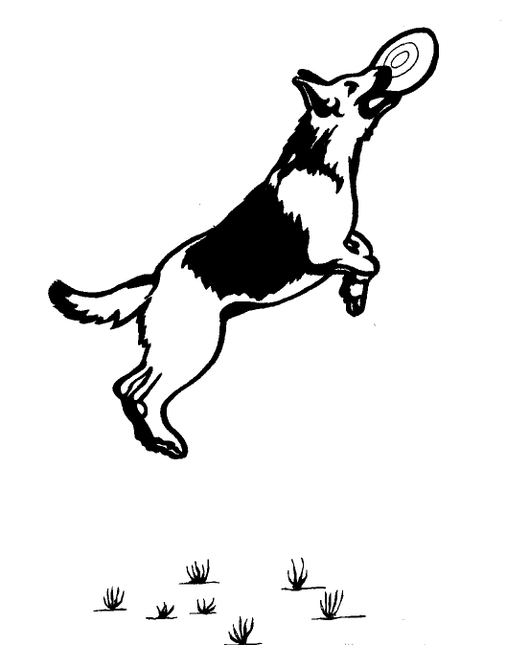 | Personality - Courage - Health - Brains - Beauty  CELHAUS GERMAN SHEPHERDS  Cel Hope  4817 Big Horn Ave. Sheridan, WY 82801  (307) 674-4800  gsdlover@celhaus.com celhaus@fiberpipe.net  www.celhaus.com

SALES CONTRACT

WHEREAS, Cel Hope, hereinafter called "Seller", is the owner of a German Shepherd dog further described as:

Registered Name of Dog: __________________________________________________

Identification: “ ” Microchip: ____________

Call Name of Dog: Color: _________________

DOB: _____________ Place of birth: Sheridan, WY

AKC Litter Registration #: _______________ AKC Individual #: _________________________

Name & AKC# of sire: ______________________________
Name & AKC# of dam: ______________________________

Quality: _____ Pet (must be neutered)
_____ Pet Plus (could be bred if passes breeder’s required health certifications)
_____ Possible Breeding (contingent upon passing breeder’s required health certifications)
_____ Breeding (contingent upon passing breeder’s required health certifications)
_____ Working: _____________________________________________

WHEREAS, ________________________________________, hereinafter called "Buyer", is desirous of purchasing the animal described above:

NOW, THEREFORE, in consideration of the sum of eighteen hundred ($1800.00) dollars, the Seller conveys one German Shepherd dog to Buyer under the following warranties and conditions and no other warranties or conditions either expressed or implied.

1. That the above described animal is a purebred dog registerable with the AKC within 180 days following the date of purchase. The pup must be named in accordance with the German standard, with a letter assigned to each litter. This is the LL Litter, so the Buyer agrees to register this puppy as Celhaus L_____, the name beginning with the litter letter. The registration papers will be limited, meaning that no offspring of this dog may be registered unless the limited registration is officially changed through AKC by the Seller. This will only be done if the dog passes all of the breeder’s required health and temperament screenings at age two years. Required certifications include OFA hips, OFA elbows, OFA cardiac, OFA thyroid, OFA degenerative myelopathy and OFA Eyes. Dog must also be certified free of von Willebrand’s and hemophilia (bleeding disorders) and EPI (Exocrine Pancreatic Insufficiency). Dog also needs to have a Canine Good Citizen, Companion Dog title, Schutzhund BH title or other training title before Seller will lift the limited registration.
2. Buyer has been informed that in many German Shepherd males (one estimate is 25%), one or both of the testicles do not descend into the scrotum. One cannot predict when the puppy leaves the Breeder if this will happen or not since they can descend until the pup is four to five months old. Buyer is aware that, if testicles do not descend, the neutering operation will be more extensive, closer to the spay operation for females. Males will only be sold as potential breeding quality if both testicles are present in the scrotum at the vet exam at 6 - 7 weeks.
3. That the above described animal may for any reason be returned to Seller within 48 hours of purchase, at Buyer's expense, and Seller will refund to Buyer the full amount of the purchase price. As of the date of this agreement, the dog is in good health and free of communicable diseases. Buyer shall take the dog to his veterinarian for a health check within the 48 hours of purchase, at Buyer's expense. Buyer shall assume full responsibility for the health, anatomical makeup, appearance and temperament of the above described animal following said 48 hour period.
4. The animal described above is guaranteed for good temperament. It is guaranteed to OFA certify at 2 years of age, unless the animal is bred prior to hip and elbow certification. A preliminary OFA hip evaluation at approximately 1 year of age is strongly urged. By signing this contract, the buyer acknowledges they have been informed that hip and elbow dysplasia are polygenetic recessive conditions, and as such, are not predictable. No one can guarantee the genetic makeup of a puppy; even with parental certifications, dysplasia can and does occasionally occur. Buyer also acknowledges that they understand that young bones do not properly calcify until 12 months of age and growth plates do not close until closer to 18 months of age. Buyer agrees they will not allow environmental conditions to adversely affect the development of the hip and elbow structure or stress the puppy’s skeletal structure before 12 months of age by hard work, jumping or intense exercise, which can cause calcium deposits and/or early arthritis.
5. Buyer is aware if they allow the dog to engage in activities that would stress joints as a puppy or before growth plates are closed, that arthritic condition can develop and can affect the dog in later life. Activities include, but are not limited to, exercise on hard unyielding surfaces, continuous running, particularly with owners who trail ride horses or run regularly, repetitive jumping, repetitive stair climbing, training in competitive dog sports, or any activity that may cause injury. Frisbee or ball catching often causes other injuries that are common, and are activities that should be avoided; jumping to catch a toy is the most common cause of ACL tears in the dog.
6. Animals sold as potential breeding quality are guaranteed against disqualifying faults as described in the attached breed standard. In the event of faulty hips, elbows or temperament, of failure to work in the above specified category, or disqualifying faults in a dog sold as breeding quality, the Seller agrees to replace to Buyer another dog of equal purchase value ($1,800.00), as determined by Seller, and the animal described above shall be returned to Seller at Buyer's expense.
7. The buyer swears that he is not acting as an agent in the purchase of this animal and is not associated with a pet animal broker, and that the above described dog will remain solely in his custody.
8. Ownership and/or possession of this dog will not be transferred without the written consent of the breeder. The breeder will accept the return of this dog at any time the purchaser decides not to keep the above described dog; however the breeder is not obligated to refund any or the entire purchase price except as stated in #2 above. Buyer has been advised to place this contract with his will or add a clause to said will that the breeder will be notified and the dog returned to breeder if no other arrangements for its care have been specified.
9. Buyer pledges as a very minimum to provide quality food that will not promote excessive growth or obesity (Holistic Select Large Breed Puppy is recommended), to complete puppy vaccinations and supply yearly boosters, to keep the above described dog with them in the house or, for short periods, in a secure fenced area with adequate shelter. Breeder recommends that puppy food should be discontinued by seven months of
age and a lower protein adult food (Holistic Select Adult Lamb is recommended) should be provided.
10. Buyer also pledges that the dog will be a valued family member with frequent human interaction and socialization. This dog or bitch is sold with the understanding that it was to go to carefully selected parties and that Buyer has AVOWED the dog or bitch would become a member of the family, loved and cherished, live in the house with them and be a part of daily life and activities. In the event of neglect or abuse of the above described dog, the breeder may repossess the dog without obligation to refund the purchase price. Neglect or
abuse may consist of but need not be confined to the following: improper feeding resulting in malnutrition or health problems, inadequate veterinary care, insufficient shelter or inhumane living conditions (chaining, left outside for long periods, etc.)
11. All controversies and/or disputes arising under this contract are subject solely and exclusively to the laws of the State of Wyoming.
12. This writing constitutes the full agreement of the parties.

WHEREFORE, the above named Seller and Buyer have executed the foregoing contract of sale at _____ a.m./p.m. on this _____ day of _________, 2016, at Sheridan, State of Wyoming.

Buyer (signature): _________________________________________________________________

Buyer (print): _________________________________________________________________

Mailing Address: _________________________________________________________________

City/State/Zip: _____________________________ Phone: ____________________________

e-mail address: _________________________________________________________________

Seller: __________________________________________________________________

